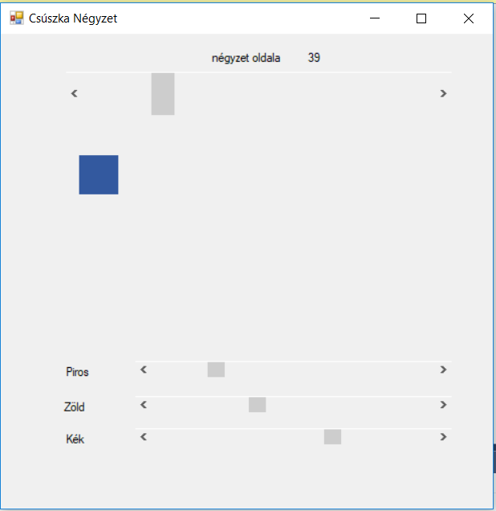

using System;

using System.Collections.Generic;

using System.ComponentModel;

using System.Data;

using System.Drawing;

using System.Linq;

using System.Text;

using System.Threading.Tasks;

using System.Windows.Forms;

namespace csuszka

{

public partial class Form1 : Form

{

public Form1()

{

InitializeComponent();

}

private void SBnegyzeth_ValueChanged(object sender, EventArgs e)

{

lbl.Text = "" + SBnegyzeth.Value;

lblnegyzet.Width = SBnegyzeth.Value;

lblnegyzet.Height = SBnegyzeth.Value;

}

private void hScrollBar2_Scroll_1(object sender, ScrollEventArgs e)

{

lblnegyzet.BackColor = Color.FromArgb(sbpiros.Value, sbzold.Value, sbkek.Value);

}

private void sbzold_Scroll(object sender, ScrollEventArgs e)

{

lblnegyzet.BackColor = Color.FromArgb(sbpiros.Value, sbzold.Value, sbkek.Value);

}

private void sbkek_Scroll(object sender, ScrollEventArgs e)

{

lblnegyzet.BackColor = Color.FromArgb(sbpiros.Value, sbzold.Value, sbkek.Value);

}

private void lblnegyzet_Click(object sender, EventArgs e)

{

}

private void SBnegyzeth_Scroll(object sender, ScrollEventArgs e)

{

}

}

}